### শিক্ষা নিয়ে গড়বো দেশ তথ্য-প্রযুক্তির বাংলাদেশ

**Bangabandhu Sheikh Mujibur Rahman Digital University, Bangladesh**

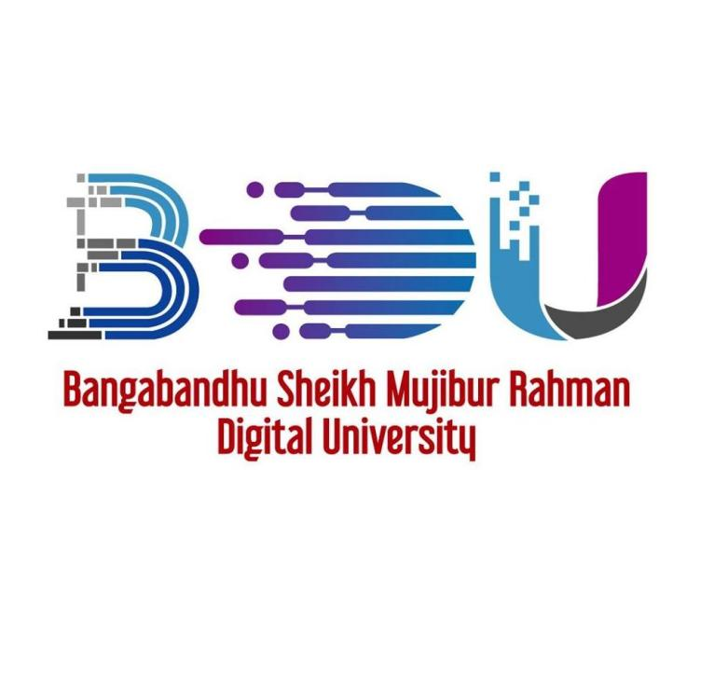

LAB REPORT-05

**COURSE NO.- PROG 112**

**COURSE TITLE- OBJECT ORIENTED PROGRAMMING SESSIONAL**

**SUBMITTED BY**

Mehrin Farzana

ID: 2101013

Department of IRE

Session :2021-2022

Bangabandhu Sheikh Mujibur Rahman Digital University, Bangladesh

**SUBMITTED TO**

Md.Toukir Ahmed

Lecturer

Department of IRE

Bangabandhu Sheikh Mujibur Rahman Digital University, Bangladesh

**Date of Submission: 14 August, 2023**